SimSurvey: an R package to optimize the design and analysis of fisheries surveys by simulating spatially-correlated fish stocks

Paul M. Regular, Fran Mowbray, et al.?

Fisheries and Oceans Canada, Northwest Atlantic Fisheries Center, 80 East White Hills, St. John’s, Newfoundland and Labrador, A1C 5X1, Canada

# Summary

**1.** Age-structured fish stocks often show complex spatial and temporal dynamics, creating challenges in designing and implementing effective population surveys. Inappropriate sampling designs can potentially lead to both under-sampling (reducing precision and increasing the risk of bias) and over-sampling (through the extensive sampling of correlated metrics).

**2.** For assessments based on fisheries-independent surveys, the ability to estimate population parameters is affected by multiple levels of sampling, such as the number of fishing sets and sub-sampling the fish captured to measure biological characteristics (e.g. lengths or ages). Multiple analysis approaches are also now available.

**3.** Though simulations are a useful tool for exploring the efficacy of specific sampling strategies and statistical methods, complex fish population structure has limited the number of tools that allow for simulation testing of a range of sampling and analytical pathways for fisheries-independent survey data.

**4.** Here we introduce the R package **SimSurvey**, which has been designed to simplify the process of simulating surveys of age-structured and spatially-distributed fish populations. The package allows the user to simulate age-structured populations that vary in space and time and then explore the efficacy of a range of sampling protocols to reproduce the population parameters of the known population. **SimSurvey** also include a function for running a stratified-random analysis of the simulated data.

**5.** **SimSurvey** can serve as a convenient, accessible and flexible platform for simulating a wide range of sampling strategies for fish stocks that show complex structuring. Various design- or model-based approaches can then be applied to the results to test the efficacy of different analytical approaches.

**Key-words:** length and age distribution; simulation; spatial correlation; stratified analysis; survey design

# Introduction

Fisheries-independent trawl surveys have become a mainstay in the management of dynamic fish stocks as they provide indices of population abundance as well as estimates of various population characteristics such as length and age frequencies (Pennington and Strømme, 1998) and forms the basis of many stock assessments throughout the world. Efficient, effective and informed management decisions therefore require surveys and analyses that maximize information while minimizing the expense of data collection. While simulations provide a platform for exploring solutions to this optimization problem, building the necessary simulation framework is not a trivial task given the multi-stage nature of the typical sampling program and the complexity of the population processes we aim to represent. Notably, many fish stocks show age-specific patterns of aggregation, as well as age/size-specific preference for various habitat characteristics (REFs), which undermine assumptions of traditional stratified-random sampling (REFs). These complexities may explain why simulations that test the full sampling and analytical pathway of fisheries-independent surveys are rare (but see Puerta *et al.*, 2019; Schnute and Haigh, 2003).

Here we document **SimSurvey**, an R package designed to facilitate realistic simulations of fisheries-independent trawl surveys. The package has two main components, the first is functions to mimic realistic fish stocks, by simulating a spatially and age-correlated fish stock distributed across a simulated or known habitat gradient. The second component is functions to simulate various surveys of these virtual fish stocks, and package these survey results to aid in decisions about optimizing survey design and sampling protocols. This simulation framework has similarities to those presented by Schnute and Haigh (2003) and Puerta et al. (2019), however, efforts were focused on developing a series of general and accessible functions to simplify the process of testing multiple sampling scenarios and analytical pathways. The steps taken to simulate surveys of spatial, age-structure populations are outlined below, with specific emphasis of a case study that motivated this work.

# The SimSurvey package

The **SimSurvey** package was written in the programming language R (R Core Team, 2017) and, in short, the package allows for the simulation of random or stratified-random surveys of an age-structured population that varies in space and time. **SimSurvey** relies heavily on functions from the **data.table** (Dowle and Srinivasan, 2017), **raster** (Hijmans, 2016) and **plotly** (Sievert, 2018) packages for their efficient data processing, geographic and plotting facilities, respectively. All the source R code behind **SimSurvey** is available on GitHub (<https://github.com/PaulRegular/SimSurvey>) and the package can be installed via GitHub:

install.packages("devtools")  
devtools::install_github("PaulRegular/SimSurvey")

## Case study

The construction of the **SimSurvey** package was motivated by a regional need for assessing the sampling design of trawl surveys conducted along the Newfoundland and Labrador shelf by Fisheries and Oceans Canada. As a tangible first step, we focused our efforts on emulating data from the survey of cod in NAFO division 3Ps since it is one of the most dynamic and heavily sampled stocks in the region. Below we outline the equations behind a series of **SimSurvey** functions that were used to simulate survey data with similar features to data obtained by the survey of 3Ps cod. The settings were iteratively modified until it was difficult to distinguish the simulated data from real survey data; these values were set as the defaults for the main functions in the package. Here we evaluate the efficacy of alternate sampling protocol by assessing deviation between stratified estimates of abundance (Smith and Somerton, 1981) from the true abundance available to the survey. While assessing model-based analyses was an option, we focused on the design-based stratified analysis for simplicity and because of its widespread use. See Table 1 for a description of the code used to generate the case study results. Text below provides more detail on each function and also demonstrates a series of functions for visualizing the results. See Appendix 1 for an interpretation and discussion of the case study results.

Table 1 - Main function calls, with argument descriptions and associated parameter symbols, used to simulate the cod-like population used in the case study presented here. Note that the settings below largely correspond with the defaults used in the functions.

|  |  |  |
| --- | --- | --- |
| **Function call** | **Description** | **Symbol** |
| > set.seed(438) | Set random number generator seed to replicate results |  |
| > |  |  |
| > abundance <- sim_abundance( | *Simulate abundance* |  |
| + ages = 1:20, | Ages | $$a$$ |
| + years = 1:20, | Years | $$y$$ |
| + R = sim_R(mean = 30000000, | Mean recruitment | $$μ_{r}$$ |
| + log_sd = 0.5), | Standard deviation of log-recruitment | $$σ_{r}$$ |
| + Z = sim_Z(mean = 0.5, | Mean total mortality | $$μ_{Z}$$ |
| + log_sd = 0.2, | Standard deviation of total mortality (log) | $$σ_{Z}$$ |
| + phi_age = 0.9, | Correlation across ages in error around total mortality | $$φ_{δ,age}$$ |
| + phi_year = 0.5), | Correlation across years in error around total mortality | $$φ_{δ,year}$$ |
| + growth = sim_vonB(Linf = 120, | Mean asymptotic length (cm) | $$l_{∞}$$ |
| + L0 = 5, | Length at birth (cm) | $$l_{0}$$ |
| + K = 0.1, | Growth rate | $$K$$ |
| + log_sd = 0.1, | Standard deviation of the von Bertalanffy growth curve | $$σ_{l}$$ |
| + length_group = 3)) | Length group bin size for abundance at length (cm) | $$l_{group}^{N}$$ |
| > |  |  |
| > grid <- make_grid( | *Make a grid* |  |
| + x_range = c(-140, 140), | Range of grid in the x dimension |  |
| + y_range = c(-140, 140), | Range of grid in the y dimension |  |
| + res = c(3.5, 3.5), | Grid resolution (km) | $$R$$ |
| + shelf_depth = 200, | Shelf depth (km) | $$d_{shelf}$$ |
| + shelf_width = 100, | Shelf width (km) | $$w_{shelf}$$ |
| + depth_range = c(0, 1000), | Depth range (m) | $$[d_{min},d_{max}]$$ |
| + n_div = 1, | Number of divisions | $$N_{div}$$ |
| + strat_breaks = seq(0, 1000, by = 40)) | Series of depth breaks for defining strata |  |
| > |  |  |
| > distribution <- sim_distribution( | *Simulate distribution* |  |
| + sim = abundance, | Object produced by sim_abundance function |  |
| + grid = grid, | Object produced by make_grid function |  |
| + ays_covar = sim_ays_covar(sd = 2.8, | Standard deviation of age-year-space distribution | $$σ_{ξ}$$ |
| + range = 300, | Range of spatial correlation (km) | $$r$$ |
| + phi_age = 0.5, | Correlation across ages in spatial distribution | $$φ_{ξ,age}$$ |
| + phi_year = 0.9, | Correlation across years in spatial distribution | $$φ_{ξ,year}$$ |
| + group_ages = 5:20), | Make space-age-year variance equal across these ages |  |
| + depth_par = sim_parabola(mu = 200, | Depth at which abundance is typically highest (m) | $$μ_{d}$$ |
| + sigma = 70)) | Dispersion around depth of peak abundance (m) | $$σ_{d}$$ |
| > |  |  |
| > surveys <- expand_surveys( | *Define a series of surveys to test* |  |
| + set_den = c(0.0005, 0.001, 0.002, 0.005, 0.01), | Set density (km-2) |  |
| + lengths_cap = c(5, 10, 20, 50, 100, 500, 1000), | Maximum number of lengths to collect / set | $$M_{lengths}$$ |
| + ages_cap = c(2, 5, 10, 20, 50)) | Maximum number of ages to sample / length group / division | $$M_{ages}$$ |
| > |  |  |
| > tests <- test_surveys( | *Simulate and analyze surveys* |  |
| + sim = distribution, | Object produced by sim_distribution function |  |
| + surveys = surveys, | Object produced by expand_surveys function |  |
| + n_loops = 1000, | Number of times to simulate each survey |  |
| + q = sim_logistic(k = 2, | Steepness of logistic curve of catchability | $$k$$ |
| + x0 = 3), | Midpoint of logistic curve of catchability | $$x_{0}$$ |
| + trawl_dim = c(1.5, 0.02), | Trawl dimensions (km) - i.e. area covered by a trawl | $$A_{trawl}$$ |
| + length_group = 1) | Length group bin size for age sampling (cm) | $$l_{group}$$ |

*Caution:* as written, the test_surveys function call may take days or weeks to run. Run duration can be decreased by running multiple simulations per loop (n_sims argument) and by running the loops in parallel (cores argument). See help file for more details (?test_surveys).

## Simulate abundance

The simulation starts with a common cohort model where the abundance at age $a$ in year $y$ ($N_{a,y}$) equals the abundance of that cohort in the previous year multiplied by the survival rate, which is expressed in terms of total mortality ($Z_{a,y}$):

$$N_{a,y}=N_{a-1,y-1}e^{-Z_{a-1,y-1}}$$

Here, numbers at age in the first year are filled via exponential decay, $N_{a,1}=N_{a-1,1}e^{-Z_{a-1,1}}$, numbers at age 1 (i.e. recruits) vary around a baseline value, $log(N_{1,y})=log(μ_{r})+ϵ_{y}$, and total mortality is set to a baseline level plus process error, $log(Z_{a,y})=log(μ_{Z})+δ_{a,y}$. The error around the recruitment process was set to follow a random walk, $ϵ_{y}∼N(ϵ_{y-1},σ_{r}^{2})$, and the process error was simulated using the covariance structure described in Cadigan (2016), $δ_{a,y}∼N(0,Σ_{a,y})$. The covariance across ages and years is controlled by a process error variance parameter ($σ_{δ}^{2}$) along with age and year correlation parameters ( $φ_{δ,age}$ and $φ_{δ,year}$, respectively). This structure allows for autocorrelation in process errors across ages and years (i.e. total mortality can be made to be more similar for fish that are closer together in age and time). Abundance at age is then converted to abundance at length using the original von Bertalanffy growth curve (Cailliet *et al.*, 2006):

$$log(l)=log(l_{∞}-(l_{∞}-l_{0})e^{-Ka})+ε$$

Where $l_{∞}$ is the mean asymptotic length, $l_{0}$ is length at birth, $K$ is the growth rate parameter and the error is assumed to follow the normal distribution, $ε∼N(0,σ_{l}^{2})$. Abundance in discrete length groups, $l_{group}^{N}$, was determined by using this formula to calculate the probability of being within a specific length group given age and then using the resultant length-age-key to convert abundance at age to abundance at length. Overall, this formulation allows for the simulation of an array of population dynamics that one might expect to observe.

Abundance is simulated using the sim_abundance function and the settings used for our case study are shown in Table 1. These settings are also the defaults of the function. This function has a simple structure and requires the specification of a series of ages and years along with functions for simulating recruitment (R), total mortality (Z) and growth (growth). The package includes the functions sim_R, sim_Z and sim_vonB for simulating recruitment, total mortality and growth, respectively. These functions are “closures” (i.e. functions that contain data and return functions; Wickham, 2014) and this structure was chosen to avoid the repeated specifications of ages and years. The use of closures also allows users to use their own closures with a similar structure but different underlying formula. Overall, the function provides a simple tool for simulating a range dynamic age-structured populations. For instance, below we simulate a relatively long and short lived species (with default settings for variances and covariances).

set.seed(438)  
a <- sim_abundance(ages = 1:20,  
 R = sim_R(mean = 3e+07),  
 Z = sim_Z(mean = 0.5))  
b <- sim_abundance(ages = 1:6,  
 R = sim_R(mean = 1e+10),  
 Z = sim_Z(mean = 0.8))

The sim_abundance function returns a list with the sequence of ages (ages), sequence of years (years), sequence of lengths (lengths), numbers of recruits across all years (R), numbers at age in the first year (N0), total mortality matrix (Z), abundance at age matrix (N), abundance at length matrix (N_at_length) and the function supplied to the growth argument (sim_length). The growth function is retained for later use in sim_survey to simulate lengths given simulated catch at age in a simulated survey.

The package also includes several plotting function for making quick plotly-based (Sievert, 2018) interactive visuals of the simulated population. For instance, the plot_surface function can be used to make quick visuals of matrices contained within the list returned by sim_abundance. As an example, we display the abundance at age matrix (object named N in the list produced by sim_abundance; Figure 1); other names can be supplied to the mat argument to visualize a different matrix from the sim_abundance list, such as Z.

plot_surface(a, mat = "N")  
plot_surface(b, mat = "N")

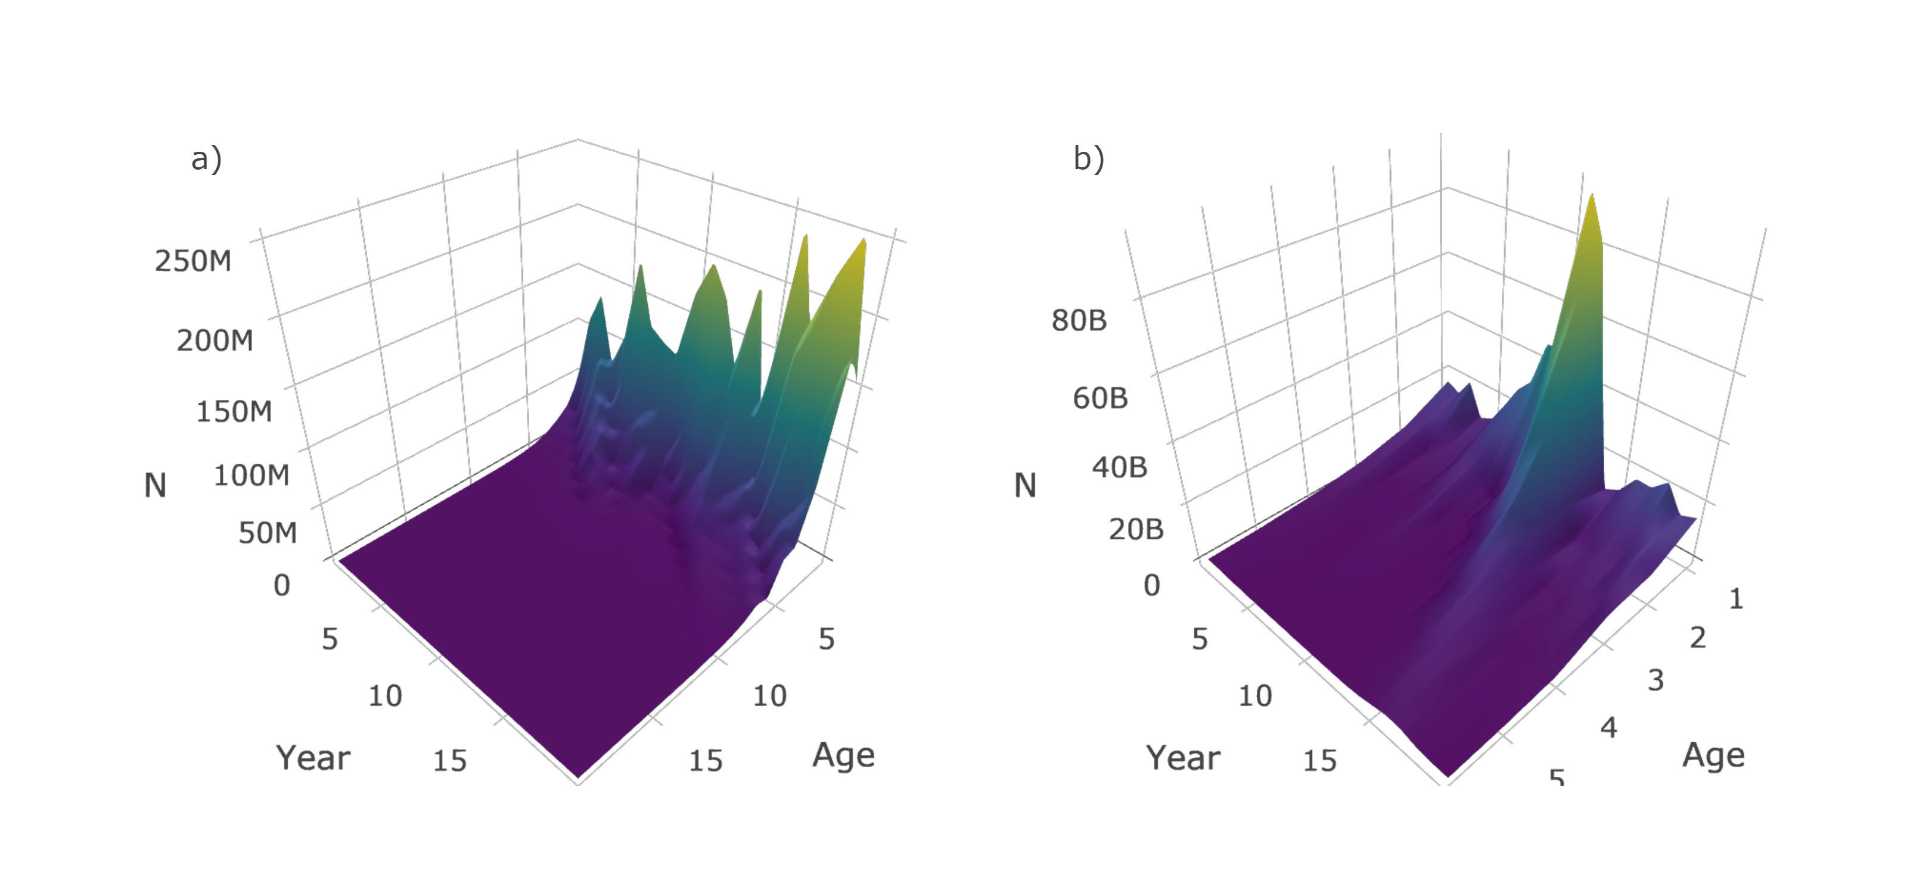

Figure 1 - Surface plots of simulated abundance at age of a relatively a) long lived (case study settings) and b) short lived species. These plots were produced by plot_surface when supplied a list produced by sim_abundance.

## Simulate spatial distribution

The next step in the simulation is to distribute the abundance at age matrix simulated using the cohort model throughout a spatial field. Here, a grid of $s$ locations is generated with a resolution of $R$ and a depth gradient. The depth gradient is set-up to have a sigmoid shape with a depth range of $[d_{min},d_{max}]$, shelf depth of $d_{shelf}$ and a shelf width of $w_{shelf}$. The grid is divided into $N_{div}$ divisions and $N_{strat}$ depth-based strata. The simulated population is distributed through the grid by simulating spatial-temporal noise controlled by a parabolic relationship with depth and covariance between ages, years and space

$$\begin{matrix}log(N_{a,y,s}) & =log(N_{a,y})+η_{a,y,s} \\ η_{a,y,s} & =\frac{(d_{s}-μ_{d})^{2}}{2σ_{d}^{2}}+ξ_{a,y,s}\end{matrix}$$

Where $d_{s}$ is the depth in a specific cell of the grid, $μ_{d}$ is the mean depth where abundance is typically highest and $σ_{d}$ controls the width or dispersion of abundance around the mean depth. This helps simulate depth preferences of particular fish. Residual noise $ξ_{a,y,s}$ is added to this depth relationship using a combination of Matérn covariance, to control the level of spatial aggregation within ages and years, and the age-year covariance described in Cadigan (2016), to control the level of similarity in distributions across ages and years. Spatial correlations were controlled by a smoothing ($λ$) and a scaling parameter ($κ$) (here we approximate $κ$ from a range parameter ($r$), $κ=\sqrt{8λ}/r$; Blangiardo and Cameletti, 2015) and correlation across ages and years was controlled by $φ_{ξ,age}$ and $φ_{ξ,year}$, respectively. The overall variance of the process was controlled by $σ_{ξ}^{2}$. In short, this formulation allows control of depth preferences, the level of spatial aggregation and the amount of age and year specific clustering. Note that $η_{a,y,s}$ is forced to sum to one in each year to ensure that the total population of each age for each year through the grid equals the number simulated by the cohort model. Also note that numbers were rounded such that a discrete number of fish are in each cell of the grid. A more detailed description of the space-age-year covariance is included in Appendix 2. Note that the distributions of specific length groups were not simulated because of the greater computational cost of storing spatially dis-aggregated abundance across all length groups.

The make_grid function is used to generate a survey grid for use in the sim_distribution function. The output from make_grid is a raster object (Hijmans, 2016) with four layers: depth, cell, division and strat. If a more detailed and realistic grid is required, users can manually generate their own survey grid using real data and this grid can be supplied as a raster to sim_distribution if the same structure is used. The package includes a manually constructed survey grid of NAFO division 3Ps (named survey_grid) and the data-raw folder in the GitHub directory includes the data and code used to construct this grid. However, for simplicity, we use make_grid to construct a square grid for our case study and the settings used are shown in Table 1. Below we generate and plot (Figure 2) a default case study grid and another grid with four divisions and a more linear gradient in depth.

a <- make_grid(n_div = 1, shelf_depth = 200,  
 shelf_width = 100, depth_range = c(0, 1000))  
b <- make_grid(n_div = 4, shelf_depth = 500,   
 shelf_width = 0, depth_range = c(0, 1000))  
plot_grid(a)  
plot_grid(b)

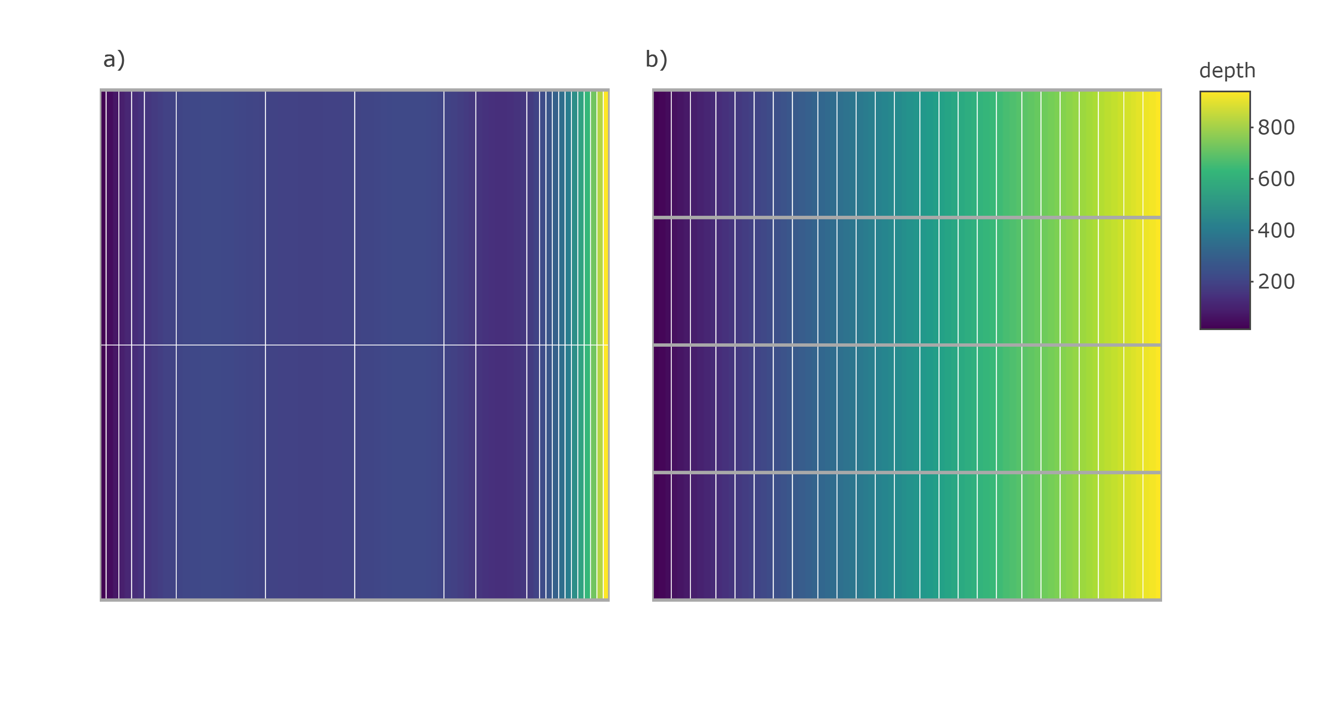

Figure 2 - Plots produced by plot_grid when supplied an raster object produced by make_grid a) using default case study settings and b) settings generates a grid with four divisions and a more linear depth gradient. In these plots, the color gradient represents depth, the grey lines delineate divisions and white lines delineate strata.

The sim_distribution function distributes the population simulated using sim_abundance throughout the grid generated using make_grid. In addition to supplying objects produced by sim_abundance and make_grid, this function requires two closures that describe the age-year-space covariance and the relationship with depth. Here we use sim_ays_covar and sim_parabola to control these relationships and a wide range of age and year specific distributions can be obtained by tweaking a few parameters in these closures. Below we run a default sim_distribution call, which generates a population that forms tight clusters that are more strongly correlated across years than ages, and another call that generates a population that is more diffuse (i.e. wider range) and exhibits stronger correlation across ages than years. Distributions can also be forced to be the same across ages and years by using the group_ages and group_years, respectively, arguments in the sim_ays_covar closure. In other words, these parameters can be modified to control the degree of age-specific clustering and inter-annual site-fidelity exhibited by the simulated population. Note that the resolution of the default grid is high and, as such, the simulations below may take minutes to complete. Also note that the key functions in the **SimSurvey** package have been set-up to be pipe (%>%; Bache and Wickham, 2014) friendly.

set.seed(438)  
a <- sim_abundance() %>%   
 sim_distribution(ays_covar = sim_ays_covar(range = 300,  
 phi_year = 0.9,  
 phi_age = 0.5))  
b <- sim_abundance() %>%   
 sim_distribution(ays_covar = sim_ays_covar(range = 2000,  
 phi_year = 0.2,  
 phi_age = 0.9))

This function retains all the data simulated by sim_abundance and adds a data.table (Dowle and Srinivasan, 2017), named sp_N, with abundance (N) split by age, year and cell. The function also retains the grid object and converts these data into a data.table, named grid_xy, with headers x, y, depth, cell, division and strat. The sp_N object can be merged with the grid_xy data by cell to associate abundance with specific locations, depth, divisions or strata. The plot_distribution function can be used to provide a quick visual of the distribution across ages and years. The code below will generate interactive plots with an Age-Year slider, however, for this paper we present a facet plot of the simulated data (Figure 3).

plot_distribution(a, ages = 1:3, years = 1:3, type = "heatmap")  
plot_distribution(b, ages = 1:3, years = 1:3, type = "heatmap")

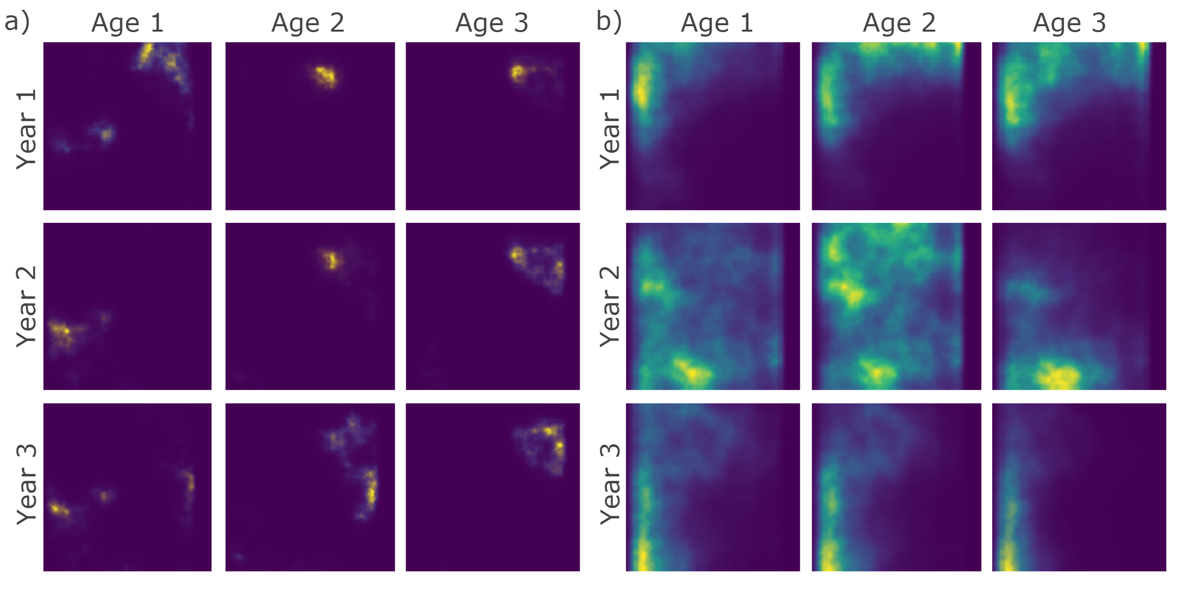

Figure 3 - Distribution plots of simulated populations that form a) tight clusters with stronger correlation through years than ages (case study settings), and b) relatively diffuse clusters with stronger correlation through ages than years. This plot is a facet of plots produced by plot_distribution when supplied simulations from sim_distribution.

## Simulate survey

The final step in the simulation is to conduct a stratified random survey over the age-year-space array generated. The area of each strata is calculated and this is used to define the number of sets to allocate to each strata under a particular set density, $D_{sets}$. The allocated number of cells are randomly selected in each strata and the number of fish caught in each set is calculated by applying binomial sampling of the fish in each sampled cell by the proportion of the area covered by the trawl and the catchability of each age:

$$n_{a,y,s}∼Bin(N_{a,y,s},\frac{A_{trawl}}{A_{cell}}q_{a})$$

Where $n_{a,y,s}$ is the number of fish sampled by a set, $A_{trawl}$ indicates the area covered by the trawl, $A_{cell}$ is the area of a grid cell (i.e. $R^{2}$ ), and $q_{a}$ is the catchability coefficient of each age. Here, catchabilities were defined using a logistic curve controlled by a steepness, $k$, and midpoint parameter, $x_{0}$. The lengths of the fish sampled by the set are then simulated using the von Bertalanffy growth equation found above in the Simulate abundance section. Depending on the number of fish caught, sub-sampling is then conducted. Specifically, a maximum number of lengths are measured per set, $M_{lengths}$, and a maximum number of ages, $M_{ages}$, are sampled per length group, $l_{group}$, per division. Such sub-sampling is common in fisheries-independent surveys as it is costly to sample every fish captured. Age determination is especially time-consuming, which is why age sampling tends to be length-stratified.

The function sim_survey can be used to simulate data from one survey over a population created using sim_distribution. The sim_survey function simulates the sampling process of the survey and, as such, requires a closure for defining catchability as a function of age and definitions of the design of the survey. Specifically, the q argument requires a closure, such as sim_logistic, for defining the probability of catching specific age groups, trawl dimensions are defined in the trawl_dim argument, and set, length and age sampling effort are defined using the set_den, lengths_cap and ages_cap arguments, respectively. Multiple simulations of the same survey can be run using the n_sims argument, however, requesting large numbers of simulations can be computational demanding depending on the processing capacity available . Below we use sim_survey to simulate two surveys over our case study population, of which one is set-up to have higher sampling effort than the other.

set.seed(438)  
pop <- sim_abundance() %>%   
 sim_distribution()  
a <- pop %>%   
 sim_survey(n_sims = 5,  
 set_den = 1 / 1000,  
 lengths_cap = 100,  
 ages_cap = 5)  
b <- pop %>%   
 sim_survey(n_sims = 5,  
 set_den = 5 / 1000,  
 lengths_cap = 500,  
 ages_cap = 25)

Again, this function retains all the objects listed in the output of sim_distribution and adds data.tables that detail the set locations (setdet) and sampling details (samp). Catchability corrected abundance matrices, named I and I_at_length, are also produced and added to the output; these matrices are useful for comparing the true abundance available to the survey to abundance estimates obtained using design-based or model-based analyses of the simulated survey data. Specific surveys can be explored using the plot_survey function, which uses plotly (Sievert, 2018) and crosstalk (Cheng, 2016) in the background to link the bubble plot of aggregate set catch to the histogram of lengths and ages sampled to facilitate explorations of set-specific catches (Figure 4).

plot_survey(a, which_sim = 1, which_year = 20)  
plot_survey(b, which_sim = 1, which_year = 20)

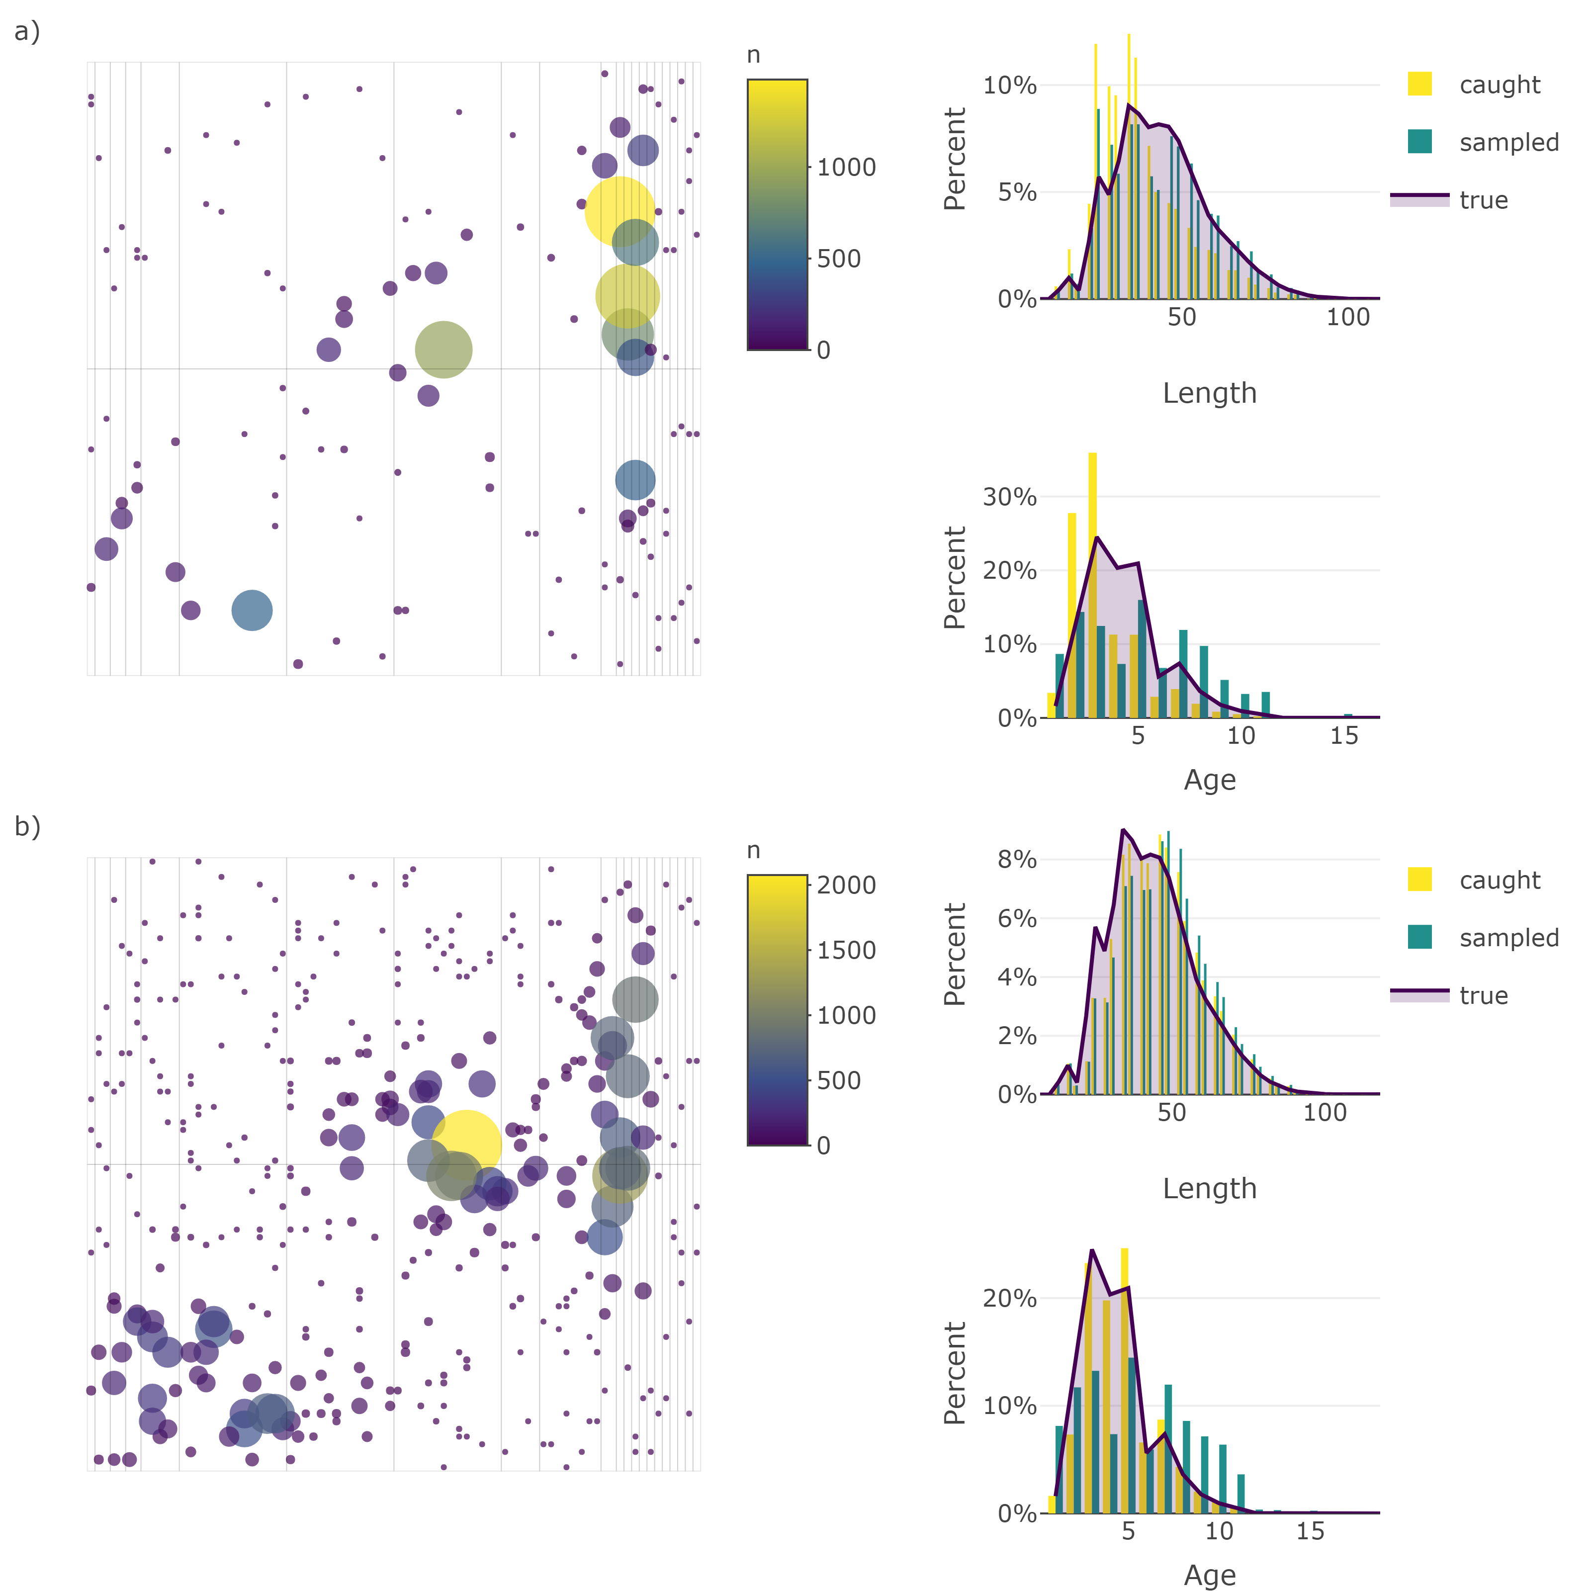

Figure 4 - Bubble plots and histograms of set catches from a simulated stratified-random survey of the case study population under relatively a) high and b) low sampling effort. Histograms of length and age composition include the distribution caught and sampled overlaid with a line of the true distribution of length and ages available to the survey. Note that the first simulation of the survey in year 20 is depicted here. These plots are produced by plot_survey when supplied survey data simulated using sim_survey.

As noted above, available RAM may limit the utility of the sim_survey function for running thousands of simulations of the same survey. The sim_survey_parallel function was therefore constructed to facilitate the running of thousands of simulations without running into RAM limitations. This function is set-up to run multiple sim_survey calls in parallel using the **doParallel** package (Revolution Analytics and Weston, 2015) and, as such, multiple loops can be run using the n_loops argument and within each loop multiple simulations can be run (controlled using the n_sims argument). Total simulations will be the product of n_loops and n_sims arguments. If more than one core (cores) is specified, then the simulations will be run in parallel to speed up the process. Low numbers of n_sims and high numbers of n_loops will be easier on RAM, but may be slower. The optimum ratio of n_sims to n_loops will depend on the amount of RAM and number of cores the user’s computer has. In any case, this function simplifies the process of running thousands of simulations of the same survey and the simulated data can then be supplied to survey-based or model-based analyses that require simulation testing.

## Stratified analysis

Once the survey data are simulated, they then need to be analyzed to obtain an index of abundance. While there are many model-based options for obtaining an index (e.g.  Thorson *et al.*, 2015), survey-based approaches, such as stratified analyses, are often used. Here we apply formula presented in Smith and Somerton (1981) to calculate stratified estimates of total abundance (${\hat{I}}_{y,k}$), abundance at length (${\hat{I}}_{l,y,k}$) and abundance at age (${\hat{I}}_{a,y,k}$). Note that estimates of total abundance are based on aggregate catch while abundance at length requires length frequencies to be scaled up using set-specific ratios of measured to caught fish, and these length frequencies are converted to age by applying a division-level age-length-key. We used root-mean-squared error (RMSE) as a measure of the precision and bias of the abundance at age estimates from each survey:

$$RMSE=\sqrt{\frac{\sum_{a=1}^{N_{a}}{\sum_{y=1}^{N_{y}}{\sum_{k=1}^{N_{k}}{(}}}{\hat{I}}_{a,y,k}-I_{a,y})^{2}}{N_{a}N_{y}N_{k}}}$$

Where $N_{a}$, $N_{y}$, and $N_{k}$ are the number of years, ages and simulations, respectively, and $I_{a,y}$ is the true abundance available to the survey (i.e. catchability corrected abundance; $I_{a,y}=q_{a}N_{a,y}$). RMSE was also calculated for abundance at length estimates, where the above formula is indexed by length groups $l$, and total abundance, which lacks a group index of $a$ or $l$.

Stratified estimates of abundance obtained are by supplying the output from sim_survey to the run_strat function. RMSE of the stratified estimates can then be calculated using the strat_error function. Results and error of a stratified analysis of one survey over a population are obtained using the following code (using default values):

set.seed(438)  
sim <- sim_abundance() %>%   
 sim_distribution() %>%   
 sim_survey() %>%   
 run_strat() %>%   
 strat_error()

The returned object will include all the objects accumulated through the sim_abundance to strat_error. The run_strat function adds three data.tables called total_strat, length_strat and age_strat that include stratified estimates of total abundance, abundance at length, and abundance at age, respectively. To this, strat_error adds data.tables ending with _strat_error or _strat_error_stats. The _strat_error objects simply contain stratified estimates of abundance (column named I_hat) with corresponding true values of abundance available to the survey (column named I) and the strat_error_stats data.frame includes metrics of mean absolute error (MAE), mean-squared error (MSE) and root-mean-squared error (RMSE).

## Testing survey protocol

Assuming a stratified analysis as the default method for obtaining an index of abundance, a series of survey protocol can be tested using the test_surveys function. Provided a simulated population from sim_distribution and a series of survey protocols from expand_surveys, this function will simulate and analyze data from each survey using the sim_survey, run_strat and strat_error functions. Like sim_survey_parallel, this function operates in parallel and allows the specification of n_sims and n_loops, and the product of these two arguments equals the number of times each survey is simulated. Keep in mind that low numbers of n_sims and high numbers of n_loops will be less demanding on RAM, but may be slower, especially if the work is spread across few cores. Because most of the default settings of the functions match the case study settings, the code below will replicate the results from our case study (see Table 1 for a more detail). The expand_surveys function sets up a series of 175 surveys to test (i.e. all possible combinations of set_den, lengths_cap and ages_cap protocol) and the test_surveys function will run 1000 simulations of each survey and compare stratified estimates of abundance to the true abundance available to the survey.

set.seed(438)  
pop <- sim_abundance() %>%  
 sim_distribution()  
  
surveys <- expand_surveys(set_den = c(0.0005, 0.001, 0.002, 0.005, 0.01),  
 lengths_cap = c(5, 10, 20, 50, 100, 500, 1000),  
 ages_cap = c(2, 5, 10, 20, 50))  
  
tests <- test_surveys(pop, surveys = surveys,  
 n_sims = 5, n_loops = 200, cores = 2)

Processing time will be system (i.e. amount of RAM and number of cores) and setting (i.e. n_loops and n_sims ratio) dependent. The test_survey function will print a progress bar, generated using the **progress** package (Csárdi and FitzJohn, 2016), which details percent completion and will also include an eta after the first step of the loop completes. Keep in mind that thousands of simulations of hundreds of survey designs may take days to run. The test_surveys function therefore includes an option for exporting intermediate results to a local directory, via the export_dir argument, and the resume_test function can be used resume a test_surveys run that had to be stopped part way through the process. The final object produced will be a list that includes all objects from sim_abundance and sim_distribution with the table of survey designs tested (named surveys) and tables produced by strat_error that end with the names _strat_error and _strat_error_stats. These tables include a survey column to allow merging of the survey protocol table with the error tables. Objects produced by sim_survey (set and sampling details) and run_strat (full stratified analysis results) are not retained to minimize object size. Like other core functions, some convenience functions are included in **SimSurvey** for creating interactive plots of the results from test_surveys. For instance, a series of plotting functions ending in _fan produces fan charts where stratified estimates of abundance from each simulated survey are converted into a series of quantiles to depict the probability that estimates fall within a particular range. True values of abundance available to the survey are overlaid on the series of probability envelopes. These plots help visually assess the level of precision and bias from a specific set of survey protocol. The three lines of code below will produce interactive fan charts for stratified estimates of total abundance, abundance at length and abundance at age, respectively(Figure 5, 6, 7).

plot_total_strat_fan(tests)  
plot_length_strat_fan(tests, years = 1:20, lengths = 1:100)  
plot_age_strat_fan(tests, years = 1:20, ages = 1:10)

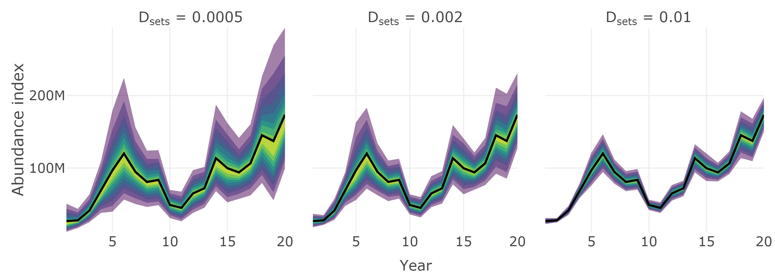

Figure 5 - Fan chart of stratified estimates of the trend in total abundance from surveys with different set densities, $D_{sets}$. The heavy black line indicates the true trend in the total population available to the survey and the color gradient represents a range of probability envelopes from 10% to 90%. This plot is a facet of plots produced by plot_total_strat_fan when supplied results from test_surveys.

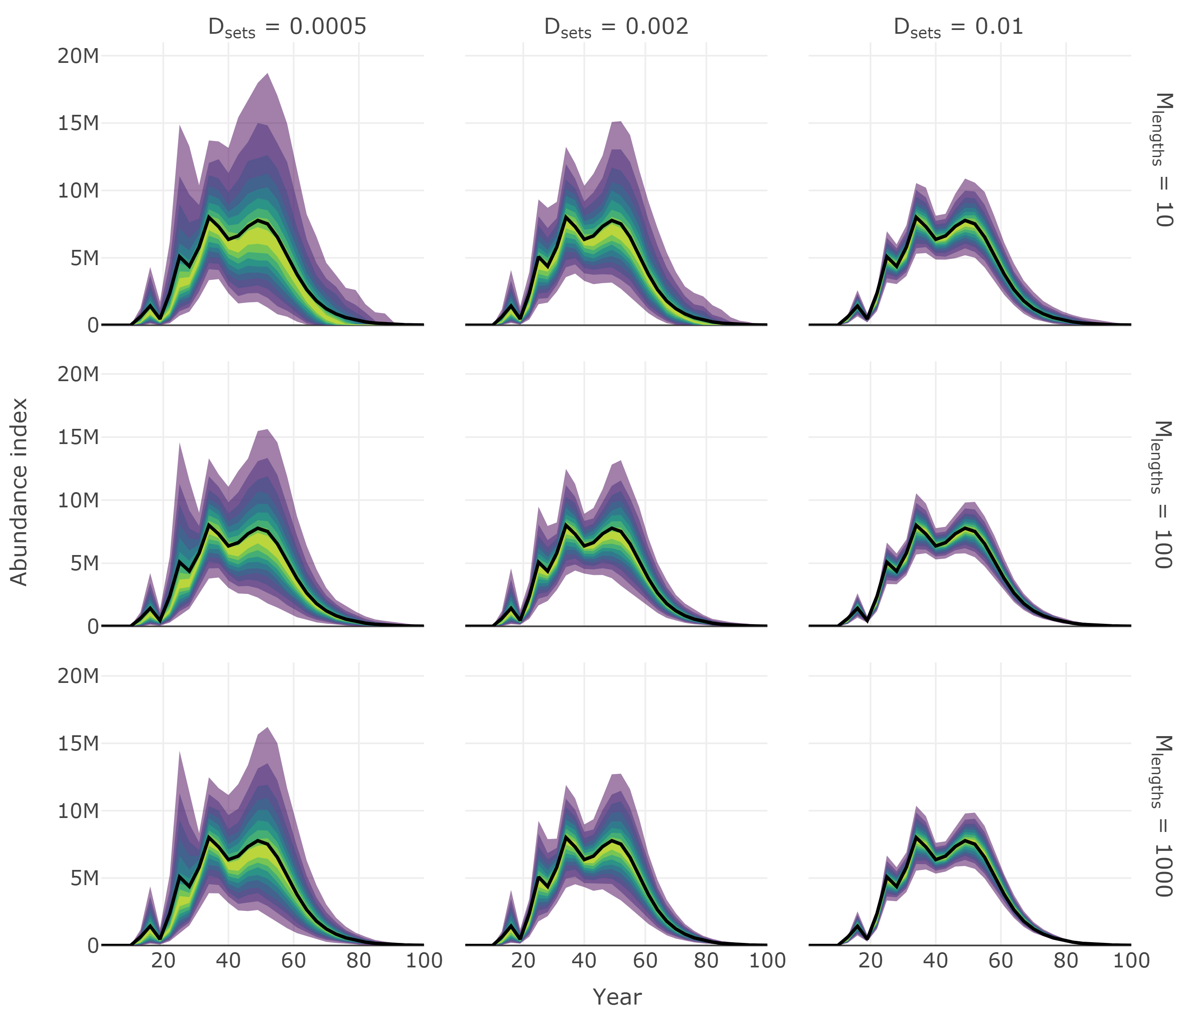

Figure 6 - Fan chart of stratified estimates of abundance at length from year seven of the simulation from surveys with different set densities, $D_{sets}$, and length sampling protocol, $M_{lengths}$. The heavy black line indicates the true trend in the total population available to the survey and the color gradient represents a range of probability envelopes from 10% to 90%. This plot is a facet of plots produced by plot_total_strat_fan when supplied results from test_surveys.

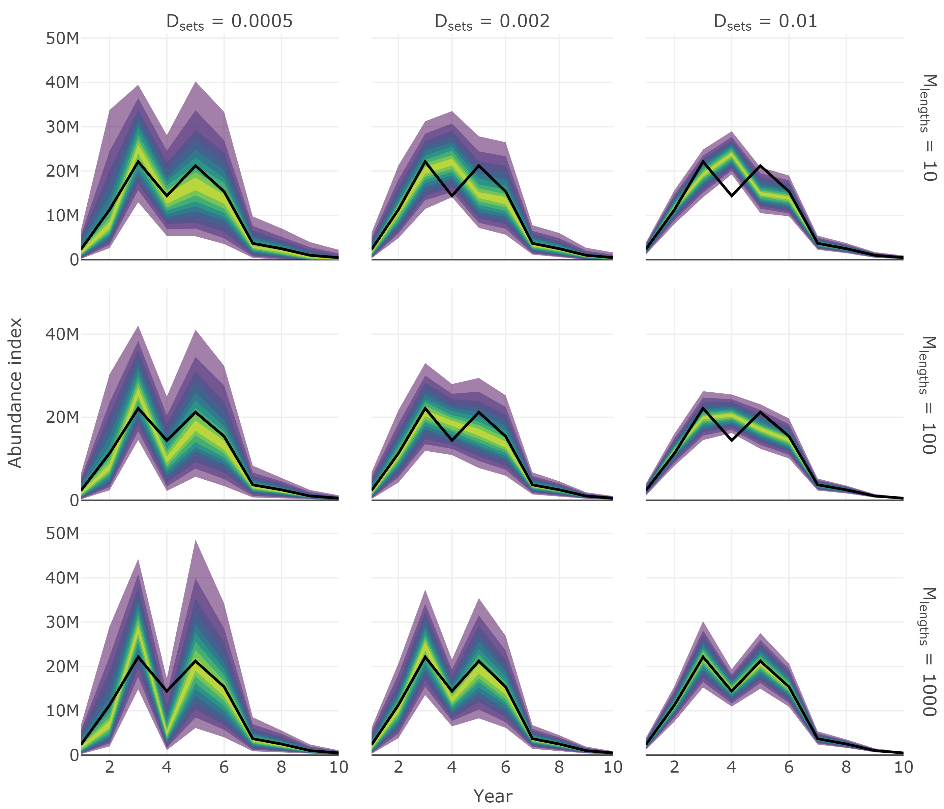

Figure 7 - Fan chart of stratified estimates of the trend in abundance at age four from surveys with different set densities, $D_{sets}$, and length sampling protocol, $M_{lengths}$. Number of ages sampled per length group, $M_{ages}$, was 10 in all scenarios. The heavy black line indicates the true trend in the total population available to the survey and the color gradient represents a range of probability envelopes from 10% to 90%. This plot is a facet of plots produced by plot_total_strat_fan when supplied results from test_surveys.

The relative performance of the surveys tested can be compared using plot_survey_rank and plot_error_surface. The plot_survey_rank function produces a divergent dot plot of the results which ranks the surveys by RMSE. Using the which_strat argument, the plot can be focused on total, length or age based stratified results. The plot_error_surface focuses solely on the age based stratified results by plotting a surface of RMSE (z-axis) by set (drop down selection), length (y-axis) and age (z-axis) sampling effort. The sampling effort axes can be rule or sample size based (plot_by = "rule" or plot_by = "samples", respectively). See figures 8 and 9 for examples of the output from the code below.

plot_survey_rank(tests, which_strat = "length")  
plot_error_surface(tests, plot_by = "rule")

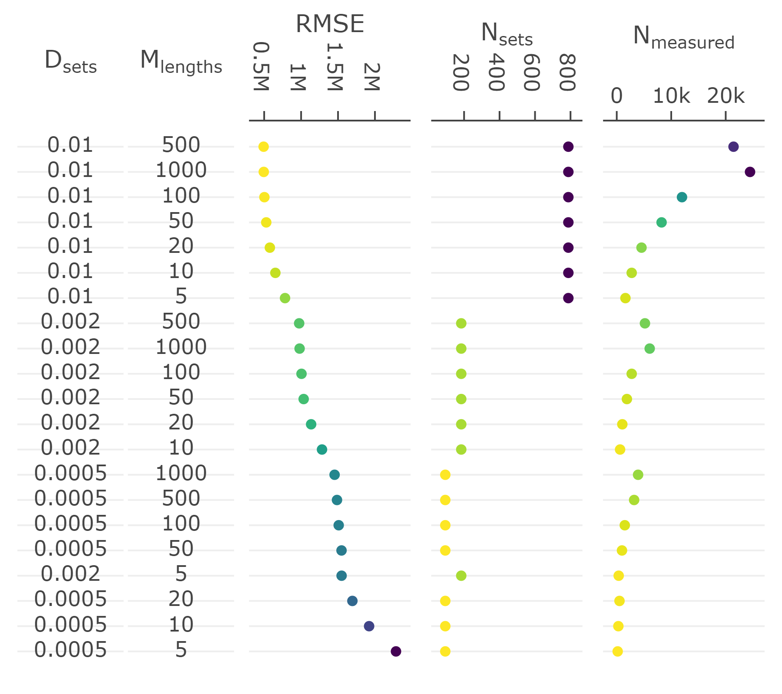

Figure 8 - Divergent dot plot of the precision and accuracy (RMSE) of length based stratified estimates of abundance, and total sampling effort (number of sets [$N_{sets}$] and length measurements [$N_{measured}$]), under various sampling protocol (set density [$D_{sets}$] and maximum number of lengths measured per set [$M_{lengths}$]).

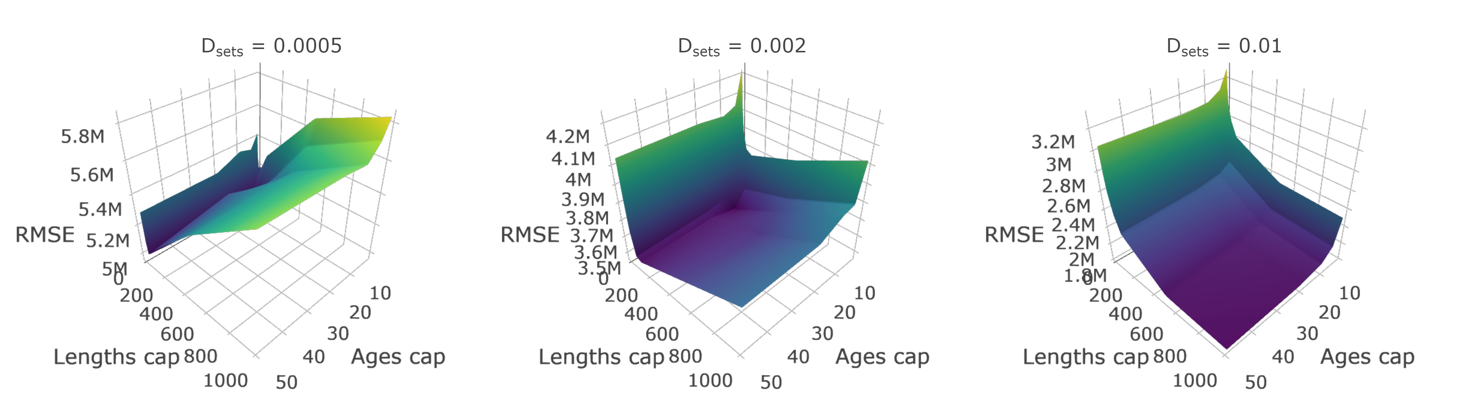

Figure 9 - Surface plots of RMSE from an array of surveys with different sampling protocol. Panels represent surveys with different set densities ($D_{sets}$), x-axes represent the maximum sampling effort of lengths per set ($M_{lengths}$), and y-axes represent the maximum number of ages to collect per length group ($M_{ages}$). This plot is a facet of plots produced by plot_error_surface when supplied results from test_surveys. Note that the z-axes scales are different across the facets.

## Assumptions

Like any model, this simulation is a simplification of a much more complex reality. For instance, the population is assumed to aggregate by age-class and be uniformly distributed within a cell, instead fish may aggregate by length and form finer-scale clusters. The survey is also an instantaneous snapshot of the population, meaning that the population is assumed to be in the same location from the beginning to the end of the survey. Also, fish are aged at random within length bins and ages are estimated without error. Finally, area trawled is assumed to be perfectly standard. These assumptions, plus a range of others, will surely under-represent the natural variability of fish populations. Nevertheless, the **SimSurvey** package provides the most realistic operating model that we are aware of for simulating stratified-random survey data from a population that varies across age, year and space dimensions.

# Research opportunities

The case study used here provides one example of ways in which **SimSurvey** can be used to simulation test the design of fisheries-independent trawl surveys. There are multiple layers to the sampling design of such surveys and the end results are linked with the way such data are analyzed. Below we outline some examples where the **SimSurvey** package may aid future research efforts.

## Design or model-based approach

The analysis of data from fisheries-independent surveys have generally been confined to design-based mean and variance estimates of abundance using standard formula for stratified-random designs (e.g.  Cochran, 1977). Nevertheless, there has long been interest in using model-based approaches to improve abundance estimates (e.g.  Smith, 1990; Berg *et al.*, 2014; Thorson *et al.*, 2015). **SimSurvey** can serve as a convenient tool for simulation testing mean and variance estimates provided by a range of different approaches (design-based analyses, bootstrap estimates, generalized additive models, geostatistical models, etc.). Moreover, the full analytical pathway for obtaining age-disaggregated estimates of abundance has rarely been simulation tested. Existing and future approaches for calculating age-based indices of abundance can be simulation tested using **SimSurvey**.

## Growth analyses

Assessing ages for a large number of fish is very time-consuming and, as such, length-stratified sampling is often used to estimate age frequencies of fish populations. The resultant sub-sample is used to construct an age-length key (i.e. the probability a fish is a specific age given length) and age frequencies are obtained by applying this key to length-frequencies obtained via more expansive random sampling. One age-length key is typically assumed to be representative of the whole stock area, however, spatial variability in the relationship may introduce bias in abundance-at-age estimates (Berg and Kristensen, 2012). Results from the case study presented here (Appendix 1) reiterate this point and **SimSurvey** may serve as a platform for testing potential model-based solutions to this problem (e.g.  Berg and Kristensen, 2012).

## Random or stratified sampling

**SimSurvey** can be used to compare the precision and bias of population estimates obtained using random or stratified sampling. Simple random sampling can be implemented using a grid with one strata (e.g. make_grid(depth_range = c(0, 1000), strat_breaks = c(0, 1000), strat_split = 0)). Sub-sampling of ages can also be random rather than length-stratified by setting the age_sampling argument in the sim_survey function to "random" rather than "stratified". This can facilitate research similar to work presented in Puerta et al. (2019).

# Future directions

Up to now, the package has focused on the effects of sampling design on the precision and bias of population estimates obtained from fisheries-independent surveys, however, the costs associated with sampling has yet to be considered. In future iterations of **SimSurvey**, we hope to add options for integrating data on the time and monetary costs associated with each level of sampling (sets, length measurements, age determination) to facilitate cost-benefit analyses. We also realize that a single fisheries-independent survey may have multiple goals as data obtained are often used to assess multiple species or to conduct community analyses. We therefore endeavor to add functions for simulating multi-species surveys. Finally, it would be useful to add an option for testing the consequences of surveys with partial coverage of a population as survey coverage is a frequent concern in stock assessment.

# Summary

The **SimSurvey** package serves as a tool for simulating stratified random surveys of dynamic populations that vary across ages, time and space. The core of the simulation is based on the widely used cohort equation and, even though the processes that define recruitment and total mortality are simple, a wide range of stock dynamics can be simulated by changing a few parameters. This base population can then be distributed through a grid and relationships with depth can be defined as can the nature of the correlation across ages, years and space. Together, two functions (sim_abundance and sim_distribution) are capable of simulating a wide range of populations with different life histories, depth associations and spatial properties. The next necessary step to generating data similar to actual observations is to conduct a survey. In this package we implement a function, sim_survey, that conducts a stratified random survey of the population. The sampling process is governed by the area covered by the trawl as well as age-specific catchability. Sub-sampling protocol (length and age sampling) can also be varied. As such, data from a wide range of surveys can be simulated.

There are a plethora of statistical models that may be tested using these simulated data, however, implementing a variety of analytical approaches was outside the scope of this package. Instead we focus on analyzing simulated stratified-random survey data using a design-based stratified analysis. A stratified analysis is facilitated using the run_strat function and the precision and accuracy of the results (e.g. RMSE) can be calculated using strat_error. This is a simple and widely-used analysis, and the speed at which it runs allows for a wide range of survey designs to be tested, via the test_surveys function, in a reasonable time-frame.

Simulation testing is an important tool in the field of fisheries science as the inferred status of fish stocks hinge on the data and models used to assess fish populations. Simulations provide an opportunity to explore survey and model performance, and such explorations are becoming increasingly important as model complexity increases. It is also important to continually assess the efficacy and efficiency of sampling programs given their costs and the constant scrutiny of the value added by such surveys. These are some of the reasons multiple simulation frameworks, including **SimSurvey**, have been developed to test the design and analyses of complex surveys. We have made **SimSurvey** as open and accessible as possible to allow the broader community to validate, reuse and improve this package. We hope that open-source sharing will extend the value of such simulation frameworks and we encourage users to extend the package for their own needs and contribute to future versions.

# Acknowledgements

**Feedback and advice:** Aaron Adamack, Jonathan Babyn, Alejandro Buren, Noel Cadigan, Karen Dwyer, Geoff Evans, Brian Healey, Paul Higdon, Danny Ings, Mariano Koen-Alonso, Joanne Morgan, Keith Lewis, Derek Osborne, Pierre Pepin, Dwayne Pittman, Don Power, Craig Purchase, Greg Robertson, Martha Robertson, Mark Simpson, Brad Squires, Don Stansbury, Peter Upward

**Package contributions:** Jonathan Babyn, Greg Robertson

**Review of previous draft:** Dave Cote, Keith Lewis, Greg Robertson

**Funding:** NSERC visiting-fellow program

# Appendix 1: case study results and discussion

## Results

A dynamic population with a patchy and age-clustered distribution was simulated for this case study (Figure 1a, 3a). In general, the parameter settings used (function defaults) dictate that all ages tend to aggregate in fairly dense clusters and that low-density zones are relatively wide-ranging. Surveys, therefore, tend to be characterized by regions with large catches interspersed with regions of no catch (Figure 4). The samples within each successful set are also dynamic and rarely include all age groups. This is because only moderate correlation ( $φ_{ξ,age}$ of 0.5) was imposed on the distributions of ages 1-5+, allowing individuals of different ages to occupy different locations. These settings were chosen to simulated data that roughly correspond to actual survey data of cod from NAFO division 3Ps, where cod between the ages of 1-5 tend to be caught at different locations.

A series of surveys were run over the simulated population (see expand_surveys call in Table 1) and stratified analyses were run on the data obtained. The stratified analyses provided estimates of total abundance, abundance at length and abundance at age Different stages of sampling affect these estimates,specifically, set density affects all estimates, length sampling affects estimates of abundance at length and abundance at age, and age sampling affects abundance at age estimates.

The effect of set density on estimates of total abundance, abundance at length and abundance at age are clear across all figures generated from the test_surveys results (Figures 5, 6, 7, 8, 9). Across all fan plots, it is clear that the probability envelopes tighten (i.e. estimates are more precise) as set density is increased (Figures 5, 6, 7). Clear declines in RMSE are also apparent in estimates of abundance at length as set density is increased (Figure 8) and there are notable differences in the scale of RMSE in estimates of abundance at age as set density is increased (Figure 9).

Compared to increases in set density, the effects of increased length sampling effort on abundance at length estimates are less clear. Regarding estimates of abundance at length, RMSE appears to reach a plateau at when length sampling effort is increased 100 measurements per set (Figure 8). Increasing the sampling rule above 100 measurements per set results in many more fish being measured, however, the increase in sampling effort is not matched with substantive declines in RMSE (Figure 8). Interestingly, it appears that measuring fewer total fish at more locations appears to be more beneficial than many fish at fewer locations (Figure 8).

All levels of sampling affect the abundance at age estimates as set catches define the magnitude of the population, length sampling define the length distribution and data from the length-stratified age sampling is used to construct an age-length-key to convert length frequencies to age frequencies. Like the abundance at length estimates, the greatest improvements to RMSE come from increasing set density rather than sub-sampling effort (Figure 9). Specifically, decreasing the age sampling protocol below 10 ages sampled per length group per division appears to result in relatively small increases to RMSE (Figure 9). Length sampling effort, in contrast, has an uneven impact depending on the set density scenario. At low set densities ( $D_{sets}$ = 0.0005 sets / km2), RMSE declines when length sampling effort is increased from around 5 to around 100 measurements per set, and RMSE starts to increase as length sampling effort is increased beyond ~100 measurements per set; in fact, RMSE values appear higher at the highest length sampling scenario (1000 measurements / set) than the lowest (5 measurements / set; Figure 9). A similar pattern is apparent under the medium set density scenario ( $D_{sets}$ = 0.002 sets / km2), however, RMSE values under the lowest and highest length sampling scenarios are of similar magnitude. Finally, RMSE continues to decline with increased length sampling effort under the high set density scenarios ( $D_{sets}$ = 0.01 sets / km2; Figure 9).

## Discussion

The simple case study presented here revealed some expected, but also a few unexpected, patterns. First, and not surprisingly, there were clear improvements to precision in all population estimates as the number of sets were increased (Sutherland, 2006). Second, stratified estimates of abundance at age were often biased and, in some cases, estimates were poorer when sub-sampling effort was increased. This result was unexpected because design-based estimators, such as the stratified analysis applied here, are expected to be unbiased (Smith, 1990) and large increases to sub-sampling effort could be expected to be relatively ineffective, but not detrimental. Results from stratified estimates of abundance at length, in contrast, better align with these expectations. By deduction, these results indicate that the issue stems from the intervening age-length key and not the design-based estimator.

Using an age-length key in conjunction with the length distribution to estimate abundance at age is standard procedure in the analysis of fisheries-independent survey data as only a small fraction of the catch is typically aged. The aging procedure is costly and time-consuming whereas length measurements are relatively easy to obtain. Ages are generally determined from length-stratified sub-samples of the catch and raw proportions of age-at-length are used to assign ages to fish in specific length groups. Age-length keys are usually constructed at larger spatial scales because there are rarely enough samples to stratify these data. Here we construct one age-length key for the division, as is done for the analysis of 3Ps cod. There is, however, a potential cost to the spatial scale of the key. Namely, it is unlikely that one age-length key is representative for the whole region because the probability of being a specific age given length varies in space (Berg and Kristensen, 2012). This would not be an issue if there was no size (age) specific clustering, however, this may not always be the case because different size groups often occur in different places because of ontogenetic habitat shifts (Dahlgren and Eggleston, 2000; Galaiduk *et al.*, 2017). For instance, it is not uncommon for populations to form distinct nursery and spawning areas (Booth, 2000; Marteinsdottir *et al.*, 2000). Because different age groups sometimes occur in different places, the translation of lengths to ages may be biased by the samples used to generate the age-length key. This bias is perhaps compounded by the length-stratified sampling of ages such that the ages sampled may be skewed towards sets with the most catch, especially under scenarios where length sampling effort is high. If this is the case, then the representativeness of the age-length key to the whole population could be diminished by excessive length sampling.

The negative consequences of excessive length sampling on abundance at age estimates are most apparent under the low set density scenarios. The precision of the estimates are also the poorest when fewer sets are conducted. Sets, however, are the most costly sample to obtain and, as such, the set densities of fisheries-independent surveys tend to be on the lower end of the scenarios presented in this paper. The set density of the multi-species survey conducted by Fisheries and Oceans Canada in the Newfoundland region, for instance, ranges between 0.001 and 0.002 sets / km2. Length sampling effort, in contrast, tends to be on the higher end of the scenarios presented here because lengths are relatively easy to obtain. Again, using Fisheries and Oceans Canada sampling protocol from the Newfoundland region as an example, it is not uncommon for length sampling effort to be capped at 500 measurements per set. The results presented in this paper paradoxically suggest that better abundance at age estimates are obtained by lowering the length sampling cap. Results also indicate that reductions to length sampling effort would not significantly impact abundance at length estimates. Nonetheless, it is hard to be prescriptive because this simulation is far from a perfect reflection of reality and it focuses on one case study. Further research is required on the consequences of some of the assumptions of this simulation as well as the interaction between age-specific clustering, length-stratified sampling and the age-length key. Ideally, the simulation would also include multiple species with different life-histories and distributions, and also integrate a cost component to assess the trade-offs between information and cost. Finally, it would be interesting to test alternate analyses of these data that may account for the spatial structure of the age-length key (e.g.  Berg and Kristensen, 2012).

While much work has yet to be done, results from the simple simulation echo the growing body of literature which concludes that extra sub-sampling is an ineffective means of improving estimates relative to sampling more locations (Pennington and Vølstad, 1994; Bogstad *et al.*, 1995; Pennington *et al.*, 2002; Coggins *et al.*, 2013; Zhang and Cadrin, 2013; Stewart *et al.*, 2014). In general, the most significant source of variation in fisheries-independent surveys stems from set-to-set variation, and not variability from individual sub-samples. This is largely because fish caught together tend to be more similar than those in the general population (Pennington and Vølstad, 1994). Therefore, if the goal of a trawl survey is to maximize information, it is likely better to stop collecting correlated samples and, instead, focus efforts on other species or the next set.

# Appendix 2: age-year-space covariance

The simulation applied in this paper was set-up to control covariance across ages, years and space. To do this we used a combination of Matérn covariance, to control the level of spatial aggregation, and the age-year covariance described in Cadigan (2016), to control the level of similarity in distributions across ages and years. As described in Appendix A in Cadigan (2016), the age-year covariance can be broken down into a series of AR(1) processes. We integrate Matérn covariance into this series of equations:

$$ξ_{a,y,s}∼\left\{\begin{matrix}MVN\left(0,\frac{σ_{ξ}^{2}}{(1-φ_{age}^{2})(1-φ_{year}^{2})}R_{s}\right) & a=1,y=1 & \\ MVN\left(φ_{year}ξ_{1,y-1,s},\frac{σ_{ξ}^{2}}{(1-φ_{age}^{2})}R_{s}\right) & a=1,y>1 & \\ MVN\left(φ_{age}ξ_{a-1,1,s},\frac{σ_{ξ}^{2}}{(1-φ_{year}^{2})}R_{s}\right) & a>1,y=1 & \\ MVN\left(φ_{year}ξ_{a,y-1,s}+φ_{age}(ξ_{a-1,y,s}-φ_{year}ξ_{a-1,y-1,s}),σ_{ξ}^{2}R_{s}\right) & a>1,y>1 & \end{matrix}\right.$$

Where $MVN$ indicates the multivariate normal distribution, $σ_{ξ}^{2}$ controls the variance of the process, $φ_{ξ,age}$ and $φ_{ξ,year}$ control correlation in the age and year dimension and $R_{s}$ is defined by Matérn correlation:

$$R_{s}=\frac{2^{1-λ}}{Γ(λ)}(κ\left|s_{i}-s_{j}\right|)K_{λ}(κ\left|s_{i}-s_{j}\right|)$$

where $\left|s_{i}-s_{j}\right|$ is the Euclidean distance between two locations, $Γ$ is the gamma function, $K_{λ}$ denotes the modified Bessel function of the second kind, and $λ$ and $κ$ control the smoothness and scale of the spatial process (Blangiardo and Cameletti, 2015). With this structure, simulated error is correlated across ages, years and space.

# References

Bache, S. M., and Wickham, H. 2014. Magrittr: A forward-pipe operator for r. <https://CRAN.R-project.org/package=magrittr>.

Berg, C. W., and Kristensen, K. 2012. Spatial age-length key modelling using continuation ratio logits. Fisheries Research, 129-130: 119–126. Elsevier B.V. <http://dx.doi.org/10.1016/j.fishres.2012.06.016>.

Berg, C. W., Nielsen, A., and Kristensen, K. 2014. Evaluation of alternative age-based methods for estimating relative abundance from survey data in relation to assessment models. Fisheries Research, 151: 91–99. Elsevier B.V. <http://dx.doi.org/10.1016/j.fishres.2013.10.005>.

Blangiardo, M., and Cameletti, M. 2015. Spatial and spatio-temporal bayesian models with r-inla. John Wiley & Sons.

Bogstad, B., Pennington, M., and Vølstad, J. H. 1995. Cost-efficient survey designs for estimating food consumption by fish. Fisheries Research, 23: 37–46.

Booth, A. J. 2000. Incorporating the spatial component of fisheries data into stock assessment models. ICES Journal of Marine Science, 57: 858–865. Oxford University Press.

Cadigan, N. G. 2016. A state-space stock assessment model for northern cod, including under-reported catches and variable natural mortality rates. Canadian Journal of Fisheries and Aquatic Sciences, 73: 296–308. NRC Research Press.

Cailliet, G. M., Smith, W. D., Mollet, H. F., and Goldman, K. J. 2006. Age and growth studies of chondrichthyan fishes: The need for consistency in terminology, verification, validation, and growth function fitting. Environmental Biology of Fishes, 77: 211–228. Springer.

Cheng, J. 2016. Crosstalk: Inter-widget interactivity for html widgets. <https://CRAN.R-project.org/package=crosstalk>.

Cochran, W. G. 1977. Sampling techniques. John Wiley & Sons.

Coggins, L. G., Gwinn, D. C., and Allen, M. S. 2013. Evaluation of Age-Length Key Sample Sizes Required to Estimate Fish Total Mortality and Growth. Transactions of the American Fisheries Society, 142: 832–840.

Csárdi, G., and FitzJohn, R. 2016. Progress: Terminal progress bars. <https://CRAN.R-project.org/package=progress>.

Dahlgren, C. P., and Eggleston, D. B. 2000. Ecological processes underlying ontogenetic habitat shifts in a coral reef fish. Ecology, 81: 2227–2240. Wiley Online Library.

Dowle, M., and Srinivasan, A. 2017. Data.table: Extension of ‘data.frame‘. <https://CRAN.R-project.org/package=data.table>.

Galaiduk, R., Radford, B. T., Saunders, B. J., Newman, S. J., and Harvey, E. S. 2017. Characterizing ontogenetic habitat shifts in marine fishes: Advancing nascent methods for marine spatial management. Ecological Applications, 27: 1776–1788. Wiley Online Library.

Hijmans, R. J. 2016. Raster: Geographic data analysis and modeling. <https://CRAN.R-project.org/package=raster>.

Marteinsdottir, G., Gudmundsdottir, A., Thorsteinsson, V., and Stefansson, G. 2000. Spatial variation in abundance, size composition and viable egg production of spawning cod (gadus morhua l.) in icelandic waters. ICES Journal of Marine Science, 57: 824–830. Oxford University Press.

Pennington, M., and Vølstad, J. H. 1994. Assessing the effect of intra-haul correlation and variable density on estimates of population characteristics from marine surveys. Biometrics, 50: 725–732.

Pennington, M., and Strømme, T. 1998. Surveys as a research tool for managing dynamic stocks. Fisheries Research, 37: 97–106.

Pennington, M., Burmeister, L.-M., and Hjellvik, V. 2002. Assessing the precision of frequency distributions estimated from trawl-survey samples. Fisheries Bulletin, 100: 74–80.

Puerta, P., Ciannelli, L., and Johnson, B. 2019. A simulation framework for evaluating multi-stage sampling designs in populations with spatially structured traits. PeerJ, 7: e6471. <https://doi.org/10.7717/peerj.6471>.

R Core Team. 2017. R: A language and environment for statistical computing. R Foundation for Statistical Computing, Vienna, Austria. <https://www.R-project.org/>.

Revolution Analytics, and Weston, S. 2015. DoParallel: Foreach parallel adaptor for the ’parallel’ package. <https://CRAN.R-project.org/package=doParallel>.

Schnute, J. T., and Haigh, R. 2003. A simulation model for designing groundfish trawl surveys. Canadian Journal of Fisheries and Aquatic Sciences, 60: 640–656. NRC Research Press.

Sievert, C. 2018. Plotly for r. <https://plotly-book.cpsievert.me>.

Smith, S., and Somerton, G. 1981. STRAP: A User-Oriented Computer Analysis System for Groundfish Research Trawl Survey Data. Canadian Technical Report of Fisheries; Aquatic Sciences No. 1030.

Smith, S. J. 1990. Use of statistical models for the estimation of abundance from groundfish trawl survey data. Canadian Journal of Fisheries and Aquatic Sciences, 47: 894–903. NRC Research Press.

Stewart, I. J., Hamel, O. S., and Rose, K. 2014. Bootstrapping of sample sizes for length- or age-composition data used in stock assessments. Canadian Journal of Fisheries & Aquatic Sciences, 71: 581–588.

Sutherland, W. J. 2006. Ecological census techniques: A handbook. Cambridge University Press.

Thomas, L., Buckland, S. T., Rexstad, E. A., Laake, J. L., Strindberg, S., Hedley, S. L., and Bishop, J. R. *et al.* 2010. Distance software: Design and analysis of distance sampling surveys for estimating population size. Journal of Applied Ecology, 47: 5–14. Wiley Online Library.

Thorson, J. T., Shelton, A. O., Ward, E. J., and Skaug, H. J. 2015. Geostatistical delta-generalized linear mixed models improve precision for estimated abundance indices for West Coast groundfishes. ICES Journal of Marine Science, 72: 1297–1310. <https://doi.org/10.1093/icesjms/fsu243>.

Wickham, H. 2014. Advanced r. Chapman; Hall/CRC.

Zhang, Y., and Cadrin, S. X. 2013. Estimating Effective Sample Size for Monitoring Length Distributions: A Comparative Study of Georges Bank Groundfish. Transactions of the American Fisheries Society, 142: 59–67.